|  |  |  |  |  |
| --- | --- | --- | --- | --- |
| |  |  | | --- | --- | | Hybrid Mobile App |  | |  |  | |
| Introduction  Cordova, Yeoman, Grunt, Angular  Compiled by Amin Shariati  Version: 0.0.3 |

Table of Contents

Version History 3

Installing Node.js® 4

Installing Git 5

Installing YEOMAN 8

Installing Gem 9

Installing Grunt 10

Installing Bower 11

Installing Cordova 12

Hologram 17

Sample Documentation Code in CSS/SCSS file 17

How to install theme for Hologram 18

Sample of hologram_config.yml 18

# Version History

|  |  |
| --- | --- |
| 0.0.1 | First Document Created with tips on how to install the applications |
| 0.0.2 | **Added Ruby and Hologram installation.** |
| 0.0.3 | **Added Cordova sample commands** |

# Installing Node.js®

Node.js® is a JavaScript runtime built on Chrome's V8 JavaScript engine. Node.js uses an event-driven, non-blocking I/O model that makes it lightweight and efficient. Node.js' package ecosystem, npm, is the largest ecosystem of open source libraries in the world.

Download URL: <https://nodejs.org/en/download/>

Check to see if Node.js is installed:

open a terminal window. type:

node -v

this will display your version

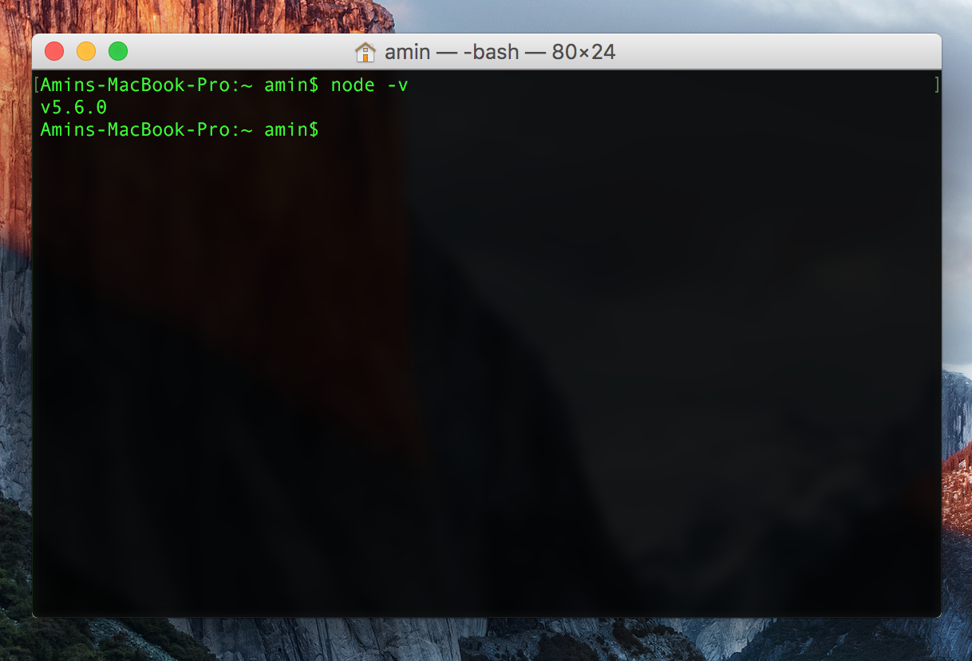

# Installing Git

Before you start using Git, you have to make it available on your computer. Even if it’s already installed, it’s probably a good idea to update to the latest version. You can either install it as a package or via another installer, or download the source code and compile it yourself.

Download URL: <https://git-scm.com/downloads>

**Installing on Linux**

If you want to install the basic Git tools on Linux via a binary installer, you can generally do so through the basic package-management tool that comes with your distribution. If you’re on Fedora for example, you can use yum:

$ sudo yum install git-all

If you’re on a Debian-based distribution like Ubuntu, try apt-get:

$ sudo apt-get install git-all

For more options, there are instructions for installing on several different Unix flavors on the Git website, at http://git-scm.com/download/linux.

**Installing on Mac**

There are several ways to install Git on a Mac. The easiest is probably to install the Xcode Command Line Tools. On Mavericks (10.9) or above you can do this simply by trying to run git from the Terminal the very first time. If you don’t have it installed already, it will prompt you to install it.

If you want a more up to date version, you can also install it via a binary installer. An OSX Git installer is maintained and available for download at the Git website, at http://git-scm.com/download/mac.

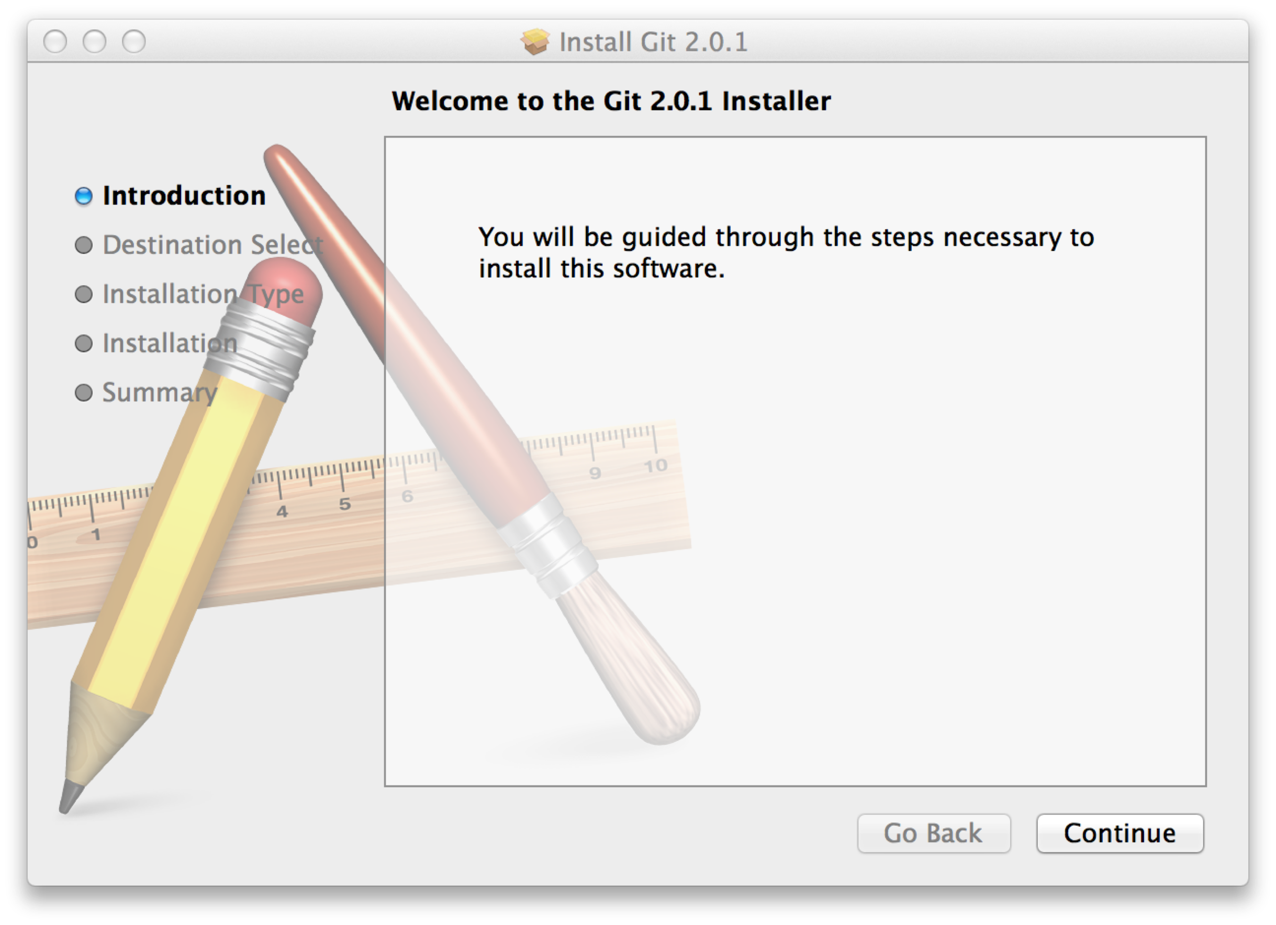

Figure 1-7. Git OS X Installer.

You can also install it as part of the GitHub for Mac install. Their GUI Git tool has an option to install command line tools as well. You can download that tool from the GitHub for Mac website, at http://mac.github.com.

**Installing on Windows**

There are also a few ways to install Git on Windows. The most official build is available for download on the Git website. Just go to http://git-scm.com/download/win and the download will start automatically. Note that this is a project called Git for Windows, which is separate from Git itself; for more information on it, go to https://git-for-windows.github.io/.

Another easy way to get Git installed is by installing GitHub for Windows. The installer includes a command line version of Git as well as the GUI. It also works well with Powershell, and sets up solid credential caching and sane CRLF settings. We’ll learn more about those things a little later, but suffice it to say they’re things you want. You can download this from the GitHub for Windows website, at <http://windows.github.com>.

Check to see if Git is installed:

open a terminal window. type:

git –version

this will display your version

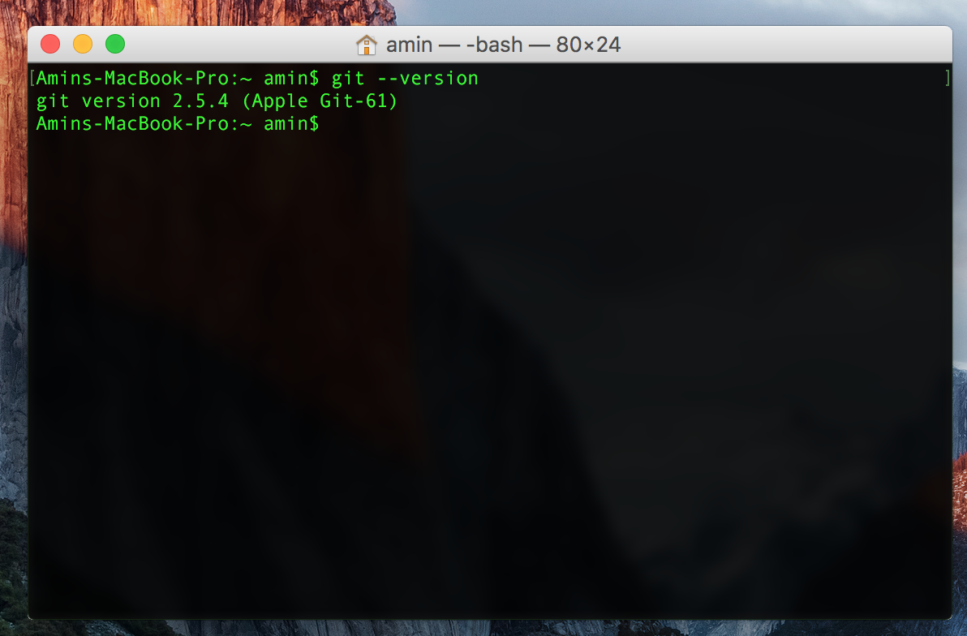

# Installing YEOMAN

Yeoman helps you to kickstart new projects, prescribing best practices and tools to help you stay productive.

To do so, we provide a generator ecosystem. A generator is basically a plugin that can be run with the `yo` command to scaffold complete projects or useful parts.

Through our official Generators, we promote the "Yeoman workflow". This workflow is a robust and opinionated client-side stack, comprising tools and frameworks that can help developers quickly build beautiful web applications. We take care of providing everything needed to get started without any of the normal headaches associated with a manual setup.

One-line install using npm:

npm install -g yo

Check to see if YEOMAN is installed:

open a terminal window. type:

yo --version

this will display your version

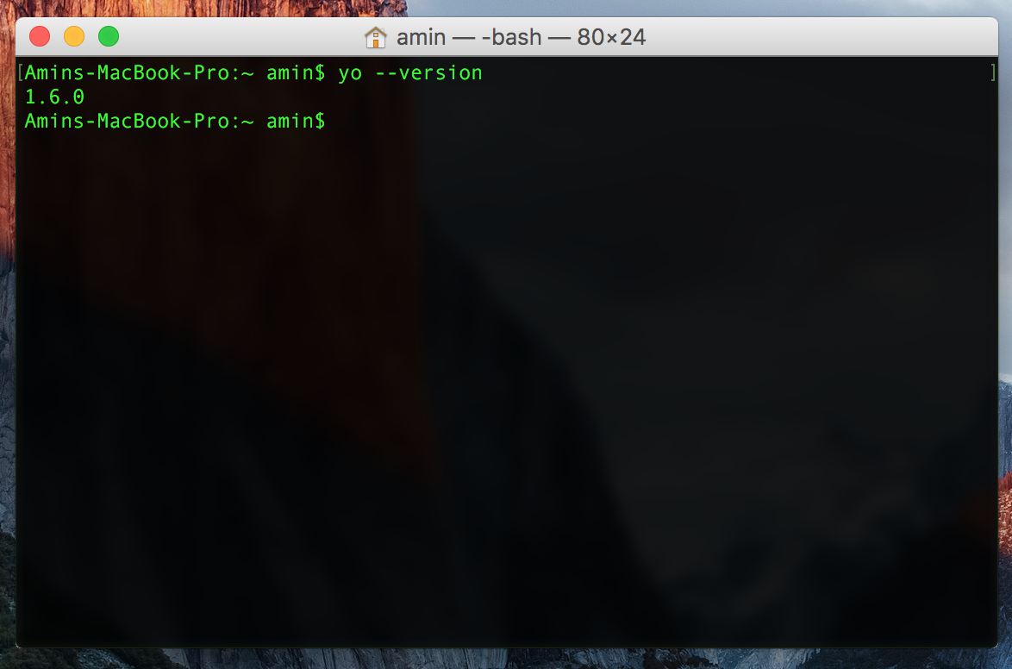

# Installing Gem

A dynamic, open source programming language with a focus on simplicity and productivity. It has an elegant syntax that is natural to read and easy to write.

Download URL: <https://www.ruby-lang.org/en/documentation/installation/>

# Installing Grunt

The Grunt ecosystem is huge and it's growing every day. With literally hundreds of plugins to choose from, you can use Grunt to automate just about anything with a minimum of effort. If someone hasn't already built what you need, authoring and publishing your own Grunt plugin to npm is a breeze.

One-line install using npm:

npm install -g grunt-cli

Check to see if Grunt is installed:

open a terminal window. type:

grunt --version

this will display your version

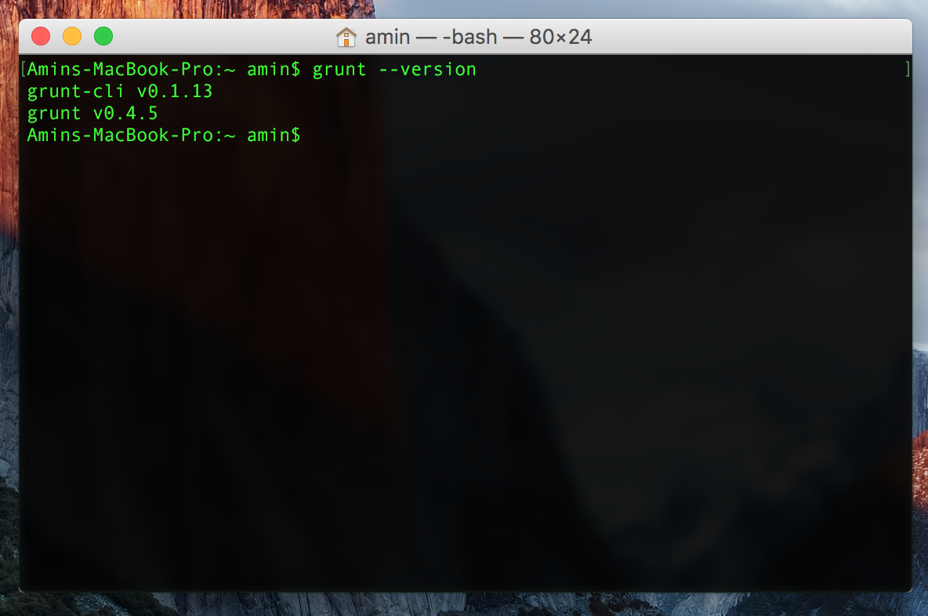

# Installing Bower

Keeping track of all these packages and making sure they are up to date (or set to the specific versions you need) is tricky. Bower to the rescue!

Bower can manage components that contain HTML, CSS, JavaScript, fonts or even image files. Bower doesn’t concatenate or minify code or do anything else - it just installs the right versions of the packages you need and their dependencies.

One-line install using npm:

npm install -g bower

Check to see if Bower is installed:

open a terminal window. type:

bower --version

this will display your version

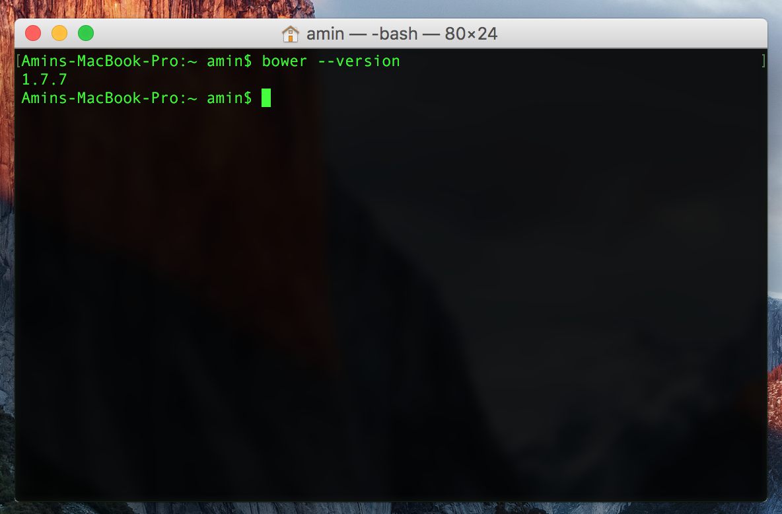

# Installing Cordova

Cordova, formerly called as Phone Gap is a platform to build Native Mobile Applications using HTML5, CSS and Java Script.

One-line install using npm:

npm install -g cordova

Check to see if Cordova is installed:

open a terminal window. type:

cordova --version

this will display your version

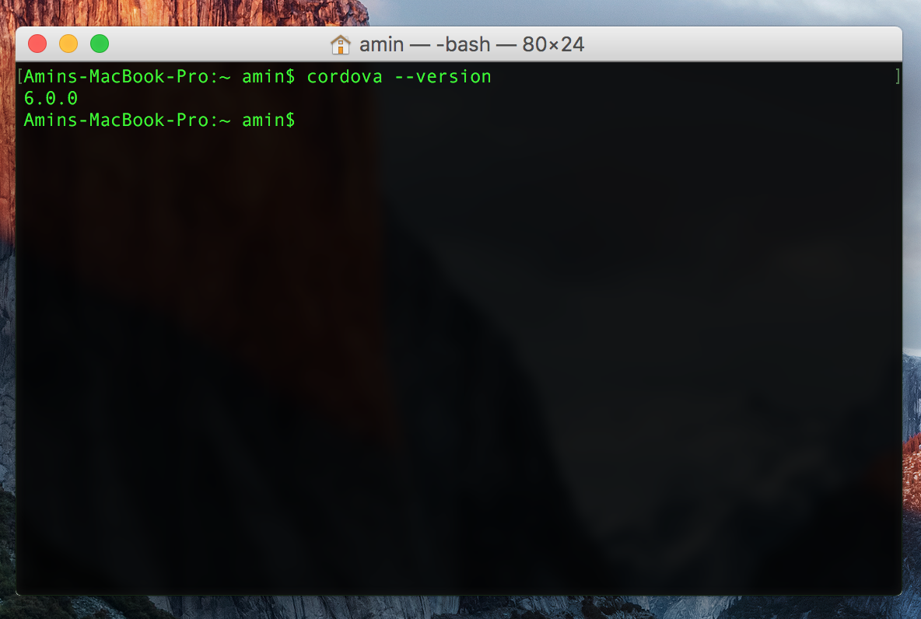

To create a new cordova project open a terminal window and type:

cordova create [YOUR PROJECT NAME] –link-to=”[YOUR PROJECT DIST FOLDER]”

Then enter the project folder and to see available platforms type:

cordova platforms

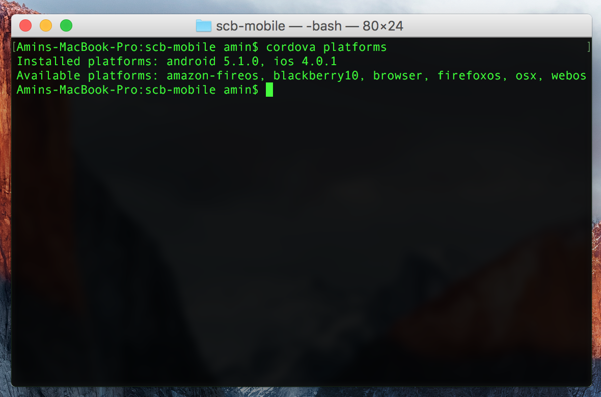

To add a platform:

cordova platform add [PLATFORM NAME]

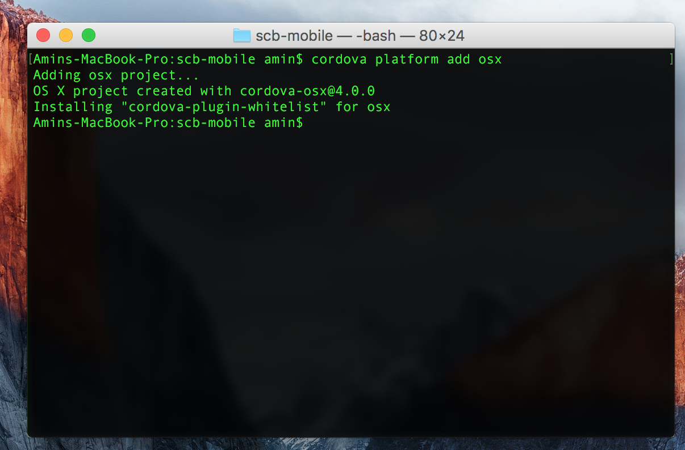

To run the project on an emulator:

cordova emulate [YOUR PLATFORM NAME]

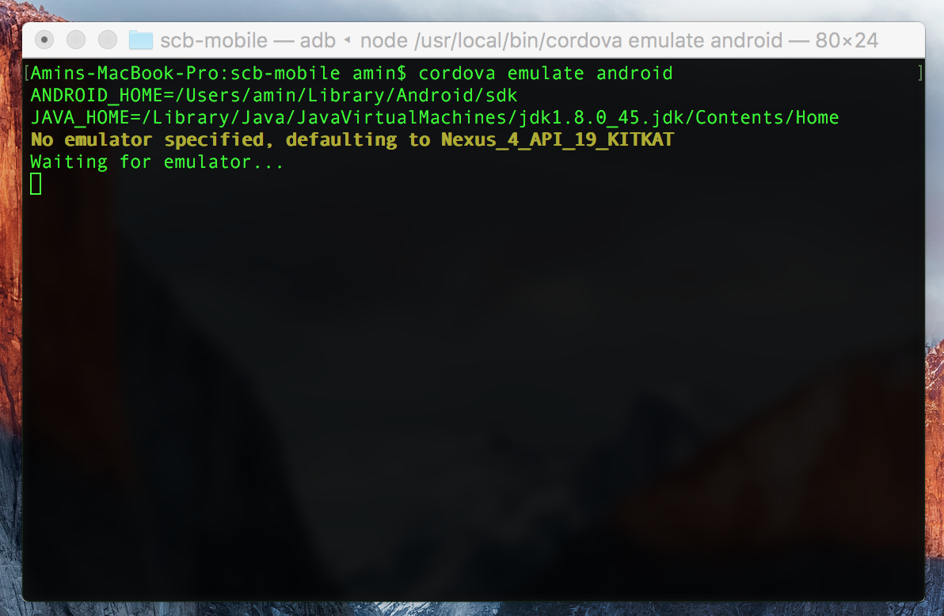

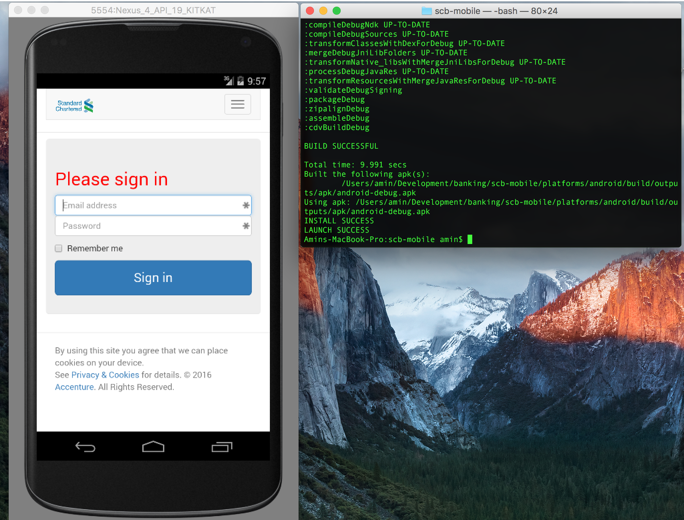

# Hologram

Hologram makes building a styleguide as easy as maintaining your CSS.Your documentation is written in your production CSS using a combination of YAML and Markdown. Markdown easily formats your docs and allows you to fall back to raw HTML for tricky parts of the styleguide. One-line install using npm:

Online URL: <https://github.com/trulia/hologram>

One-line install using gem:

gem install hologram

Then create a folder for your styleguide document and type:

hologram init

This will create a hologram_config.yml, starter _header.html and _footer.html files, and starter templates for rendering code examples. You can then tweak the config values and start documenting your css.

## Sample Documentation Code in CSS/SCSS file

/*doc

---

title: Alert

name: alert

category: basics

---

```html_example

<div class='alert'>Hello</div>

```

*/

To build the document type:

hologram

## How to install theme for Hologram

One-line install using npm:

npm install --save-dev hologram-github-theme

## Sample of hologram_config.yml

# Relative path(s) to your source files

source: app/styles

# Relative path where you want the documentation to be built

destination: styleguide

# The path that contains supporting assets for the documentation page

documentation_assets: node_modules/hologram-github-theme

# Category that will be used as the index.html (optional)

index: styleguide

# A list of relative paths to folders containing any dependencies to copy

dependencies:

- 'dist'

# The CSS files to be included in the styleguide

css_include:

- 'dist/styles/vendor.css'

- 'dist/styles/main.css'

# The JavaScript files to included in the styleguide

js_include:

- 'dist/scripts/main.js'

# The global title that is displayed at the top of the pages

global_title: Styleguide

# SCB POC Setup

TBD